Chapter 9, Problem 86.

The circuit shown in Fig. 9.86 is used in a television receiver. What is the total impedance of this circuit?

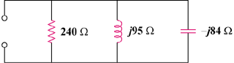

Figure 9.86
For Prob. 9.86.

